**Proceedings of the 3rd National Aerospace Propulsion Conference**

**NAPC-2020**

**Dec 17-19, 2020, B.M.S. College of Engineering, Bengaluru**

**14**

A pulsed plasma thruster performance assessment tool

|  |  |
| --- | --- |
| **Dibyesh Satpathy**  Project Assistant, KIIT Research Wing, KIIT University,  Bhubaneswar, Odisha | **Shalika Singh**  Undergraduate Student, School of Electronics Engineering, KIIT University,  Bhubaneswar, Odisha |

**ABSTRACT**

A Pulsed Plasma Thruster performance assessment tool has been developed for evaluating the various operation and design aspects of a Pulsed Plasma Thruster (PPT) which takes into input various electrical and mechanical parameters of the PPT and lays out accurate results. Correct predictions related to performance can be made when data related to the satellite or spacecraft accommodating the thruster is available, which would decide the constraints for PPT design. The software tool has been divided into 2 parts on the basis of the size of the PPT being considered, Micro-Pulsed Plasma Thruster and Large Pulsed Plasma Thruster. This tool has been developed using MATLAB and a Graphical User Interface has been developed for convenience. In order to achieve accurate analytical results, the tool has been developed by incorporating the Lumped Circuit Model, Electrode Model, Erosion Model and the Plasma Flow Model. In addition, choice for tongue shaped electrodes and flared geometries have been included apart from default PPT design, to explore the benefits of various permutations. Finally, in order to validate the applicability and veracity of the software tool, data from previously flown PPTs were used. This tool gives correct prediction of experimental results when compared to working PPTs.

**NOMENCLATURE**

|  |  |
| --- | --- |
| $$\overline{Q}$$ | mean ion charge state number in the plasma flow |
| $${\overline{Q}}_{0}$$ | initial ion charge state number in the plasma jet |
| *δp* | Thickness of the plasma sheet |
| *εo* | magnetic permittivity of free space, Fm−1 |
| *η* | Efficiency of Thruster  Ion erosion rate |
| *λ* | Latent heat of vaporization |
| *µo* | Magnetic permeability of free space, N A−2 |
| *ωo* | Natural Frequency |
| *σo* | conductivity, Ω−1*m*−1 |
| *ζ* | Damping ratio |
| *A* | Exposed propellant surface area |
| *a* | Aspect ratio of PPT |
| *C* | Capacitance |
| *d* | electrode thickness, m |
| *e*  *eo*  *Eo* | elementary charge, C  Vacuum Permittivity of free space, Fm-1  Energy of the PPT discharge |
| *ESL* | Equivalent series inductance |
| *ESR* | Equivalent series resistance |
| *h* | electrode spacing, m |
| *hprop* | Propellant bar height, m |
| *Iarc* | Arc current flowing through the circuit loop, A |
| *Ispot* | Current associated with each cathode spot, A |
| *L* | Inductance of the closed-circuit |
| l | electrode length, m |
| L’  Lo | Inductance gradient  Initial Inductance |
| *Lp* | Plasma Inductance |
| *lprop* | Propellant bar length, m |
| *Le* | Inductance of electrodes |
| *me* | mass of electron, kg |

*mablated* Mass of propellant ablated

|  |  |  |  |
| --- | --- | --- | --- |
| *mbit* | Mass bit | | |
| *Ne* | electron density, m−3 | | |
| *Ni* | ion density, m−3 | | |
| *R*  Ro | Total Resistance, Ω  Initial Resistance of the circuit, Ω | | |
| *Re* | Resistance of electrodes, Ω | | |
| *Rp* | Plasma Resistance, Ω | | |
| *So* | surface area of initial plasma flow near the mixing region, *m*2 | | |
| *Sspot* | | surface area of cathode spot near the mixing region, *m*2 |
| *Te* | | electron temperature, K |
| *Tm* | | maximum electron temperature in the plasma jet, K |
| *Tcr* | | Critical electron temperature in the plasma flow, K |
| *TEM* | | Electromagnetic Component of Thrust |
| *TET* | | Electrothermal Component of Thrust |
| *Vz* | | plasma flow velocity, *ms*−1 |
| *w* | | electrode width, m |
| *wprop* | | Propellant bar width, m |
| PPT  PTFE | | Pulsed Plasma Thruster  Polytetrafluoroethylene |

**INTRODUCTION**

# The PPT appears simple in its construction but it encompasses many complex interactions produced from the electromagnetic and electrothermal processes. The three-dimensional geometry in combination with the pulsed operation enhances the difficulty to understand those interactions quantitatively. The electrodes, by virtue of their design, conduct current in the form of an arc, thereby, leading to evaporation and acceleration of the propellant. The acceleration mechanism is either pressure generated by the electric arc, forming the electrothermal contribution or force generated from the current and the magnetic field that provides the electromagnetic part.

# The efficiency of a thruster is mainly determined by the electrical and geometrical parameters. The electrical parameters in the study comprised of the initial discharge energy, pulse frequency, resistance, inductance and capacitance. The geometrical parameters taken into consideration are the electrode's shape (rectangular or tongue), length, width, spacing, thickness and flaring (if any). The tool presented in this paper analyses the effects of the geometrical parameters, electrical parameters, propellant feeding mechanism and material of electrodes on the performance of the thruster. Depending on the aspect ratio, PPT in this study is categorized into micro and large PPT. The analytical tool suggested in the paper estimates the performance of both micro and large PPT.

**PHYSICAL CLASSIFICATION**

1. **PROPELLANT AND ELECTRODE GEOMETRY**

The inter-electrode spacing between the anode and cathode of electrodes is *h*, and the width, length and thickness are *w*, *l* and *t*, respectively. The electrodes are investigated for parallel and flared (at angle α) configuration for two shapes, rectangular and tongue.

# 

**Figure 1. Electrode Configuration in the study (2)**

In the study, we consider the aspect ratio of a thruster to determine whether it is a micro or large PPT, and is evaluated by the following equation:

|  |  |  |
| --- | --- | --- |
| $$a=\frac{h}{w}$$ |  | (1) |

The height, width and length of the propellant are taken as *hprop*, *wprop* and *lprop*, respectively. Generally, it is considered that *hprop=h*.

1. **PROPELLANT FEEDING MECHANISM**

The choice of the feeding mechanism of the propellant is a crucial step to attain optimal mass utilization. The analytical tool takes into consideration the following feed mechanisms:

1. **Breech feeding**: The propellant is fed in the forward x-direction along the acceleration of the plasma, from the breech of the thruster (2).
2. **Side feeding**: The feeding mechanism comprises of two pieces of propellant entering from each side in the opposite y-directions and is fed towards the spark plug in a direction perpendicular to the acceleration of the plasma (2).
3. **Combination feeding**: The design combines breech and side feeding mechanism and feeds the propellant in a three-dimensional way.

The analytical tool takes all the above three feeding mechanisms to help us understand the propellant ablation.

The exposed propellant surface area depends on both the propellant dimension and the feed mechanism and is evaluated as below (1):

|  |  |  |
| --- | --- | --- |
| $$A=n*h_{prop}*w_{prop}$$ |  | (2) |

# where *n* is 1, 2 and 3 for breech, side and combination feeding mechanism, respectively.

**PROPELLANT ABLATION**

PPT operates by discharging stored energy into the propellant located between two electrodes. When energy is supplied using an external device, the propellant ionizes, leading to the formation of low resistance plasma, which electrically connects the capacitor to the electrodes, allowing it to discharge. Low currents induce high resistance which creates a strong magnetic field within the electrodes. The energy released by the capacitor further ionizes the propellant forming the additional plasma. The cross product between the current density flowing through the plasma and the magnetic fields create a force called the Lorentz force, which accelerates the plasma bulk along the thrust axis. The coupled LCR system forms a multi-phase plasma discharge which is in the order of tens of microseconds. The complete process, when repeated regularly for a while, helps to create exploitable thrust for a satellite propulsion module (4).

The mass of ablated propellant in the study assumes the following form (3):

|  |  |  |
| --- | --- | --- |
| $$m_{ablated}=\frac{σ_{o}δ_{p}}{λ}\frac{d}{h}\left(R_{p}^{2}+\frac{L_{p}^{2}}{LC}\right)\frac{E_{o}}{R_{o}}$$ |  | (3) |

Where, $R_{o}=1.3\sqrt{\frac{C}{L_{o}}}$ is the initial resistance of the circuit.

The ablated mass expression is considered with the assumption that the mass ablated per shot is proportional to the energy dissipated over the solid propellant. *mbit* is the mass ablated in every shot. The mass bit derivation does not assume any particular geometry.

# ANALYTICAL PPT MODEL

1. **THE EQUIVALENT CIRCUIT**

The evolution of discharge potential of a PPT is explained using a circuit model, where we assume the plasma sheet to be discrete elements of an RLC series circuit, which also varies with time. This method assists in predicting the dynamics of PPT discharge, which is essential for the development of performance scaling relations and can be used in the thruster design (1).

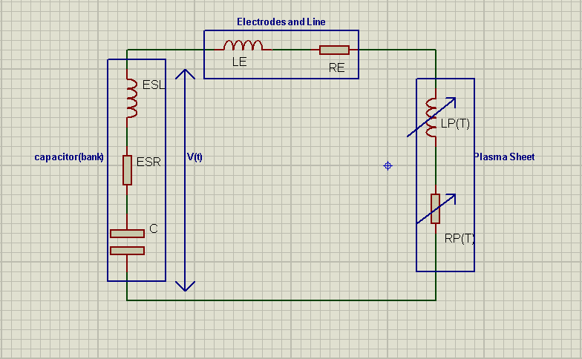

**Figure 2. Pulsed Plasma Thruster Equivalent Circuit (1)**

As depicted in Fig. 2, the circuit is composed of the thruster discharge circuit, like the electrodes (*Re* and *Le*), the capacitor and the line in between them. The capacitor bank specifically, has been represented by a typical equivalent series circuit, comprising of a constant capacitive element (*C*) in series with an inductive and a resistive element, referred to as the equivalent series inductance (*ESL*) and equivalent series resistance (*ESR*). The time variance of the plasma parameters *Rp* and *Lp* help to model the change in inductance and resistance of the discharge circuit as the current sheet propagates down the electrodes. Hence, *Rp* and *Lp* are associated with the position of the plasma sheet, which is accelerated by the Lorentz force. The equation describes the discharge potential when coupled with the momentum equation of the plasma sheet reflects the interaction between the dynamic and electrical characteristics of the discharge (1).

1. **CONSTANT ELEMENT MODEL**

The equivalent circuit mentioned in Fig. 2 is considered as a simple RLC circuit, by assuming that inductance variation per unit length is zero and consequently, *L* is constant. In this study, for thrusters with parallel electrode plates and small aspect ratio, i.e. *a* <2, the inductance per unit length assumes the following form (1):

|  |  |  |
| --- | --- | --- |
| $$L^{'}=μ_{0}\frac{h}{w}$$ |  | (4) |

For thrusters with larger aspect ratio, i.e. *a* >2, the inductance of a closed circuit is evaluated as below (1):

|  |  |  |
| --- | --- | --- |
| $$L=0.4l\left(\ln{\frac{h}{w+d}}+\frac{3}{2}-\frac{h}{l}+0.22\frac{w+d}{l}\right)$$ | [µH] | (5) |

Hence, for a larger aspect ratio, the inductance variation per unit length is considered as below (1):

|  |  |  |
| --- | --- | --- |
| $$L^{'}=0.6+0.4\ln{\frac{h}{w+d}}$$ | [µH/m] | (6) |

Electrode dimensions are supposed to be chosen wisely to maximize the value of $L^{'}$. Important non-uniformities are observed if the aspect ratio is too high, thereby, reducing the acceleration process efficiency. Additionally, an increase of electrode spacing would also increase the plasma resistance, consequently reducing the current parameter $ψ$ and the electromagnetic impulse. The choice of the electrode spacing is determined by the inductance per unit length, available energy and also by the capacitor voltage. If the electrode spacing is increased without correspondingly enhancing the voltage, the electrical field between the plates would decrease. Therefore, choosing a very high value of spacing might negatively influence the performances (1).

The equivalent circuit is described by the following expression (3):

|  |  |  |
| --- | --- | --- |
| $$V=V_{0}-\frac{1}{C}\int_{0}^{t}{ⅈ\left(τ\right)ⅆτ}=V=Rⅈ\left(t\right)+\frac{d}{ⅆt}(L i(t))=Ri(t)+L\frac{ⅆi\left(t\right)}{ⅆt}+i(t)\frac{ⅆL}{ⅆt}$$ |  | (7) |

For our study we consider the simplified voltage equation (1):

|  |  |  |
| --- | --- | --- |
| $$V=V_{0}-\frac{1}{C}\int_{0}^{t}{ⅈ\left(τ\right)ⅆτ}=V=Ri(t)+L\frac{ⅆi\left(t\right)}{ⅆt}$$ |  | (8) |

where, R=Rc+Re+Rp and L= Lc+Le+Lp.

The solution for the circuit current for the above equation is considered as below (1):

|  |  |  |
| --- | --- | --- |
| $$\frac{d^{2}ⅈ\left(t\right)}{ⅆt^{2}}+2{ζω}_{0}\frac{ⅆⅈ(t)}{ⅆt}+ω_{0}^{2}ⅈ\left(t\right)=0$$ |  | (9) |

Where, $ω_{0}$ represented the natural frequency of the system. It is defined as below (1):

|  |  |  |
| --- | --- | --- |
| $$ω_{o}= \frac{1}{\sqrt{LC}}$$ |  | (10) |

and $ζ$ described the damping ratio, mentioned below (1):

|  |  |  |
| --- | --- | --- |
| $$ζ=\frac{R}{2}\sqrt{\frac{C}{L}}$$ |  | (11) |

Equation (9) depicts a harmonic oscillator whose value illustrates the current waveform in three ways, overdamped (for $ζ$ >1), critically damped (for $ζ$ =1) or underdamped (for $ζ$ <1).

Hence, for overdamped current waveform, when $ζ$ >1, or when $C>\frac{4L}{R^{2}}$, the discharge current doesn't reverse and can be evaluated as below (1):

|  |  |  |
| --- | --- | --- |
| $$ⅈ\left(t\right)=\frac{V_{0}}{L\sqrt{ζ^{2}-1}ω_{0}} e^{-ζω_{0}t}\sinh{\sqrt{ζ^{2}-1}ω_{0}t}$$ |  | (12) |

The voltage across the electrodes, in this case, is expressed as below (1):

|  |  |  |
| --- | --- | --- |
| $$V\left(t\right)=\frac{ζ}{\sqrt{ζ^{2}-1}} V_{0} e^{-ζω_{0}t}\sinh{\sqrt{ζ^{2}-1}ω_{0}t}+V_{0} e^{-ζω_{0}t}\cosh{\sqrt{ζ^{2}-1}ω_{0}t}$$ |  | (13) |

When the current waveform is critically damped, at $ζ$ =1, or when $C=\frac{4L}{R^{2}}$, the discharge current and the corresponding voltage becomes (1):

|  |  |  |
| --- | --- | --- |
| $$ⅈ\left(t\right)=\frac{V_{0}}{L} te^{-ω_{0}t}$$ |  | (14) |

|  |  |  |
| --- | --- | --- |
|  |  | (15) |

Both the overdamped and critically damped current waveform depicts the circuit response that decays and returns to zero to attain an equilibrium, in the fastest possible time without oscillating. That corresponds to the best and fastest way of transferring energy stored in the capacitor to the other elements of the circuit.

When $ζ$ <1, or when $C<\frac{4L}{R^{2}}$, the waveform is underdamped, and the current reverses multiple time before the discharge extinguishes. The current and voltage for the underdamped case is mentioned below (1):

|  |  |  |
| --- | --- | --- |
| $$ⅈ\left(t\right)=\frac{V_{0}}{L\sqrt{{1-ζ}^{2}}ω_{0}} e^{-ζω_{0}t}\sin{\sqrt{1-ζ^{2}}ω_{0}t}$$ |  | (16) |

|  |  |  |
| --- | --- | --- |
|  |  | (17) |

The Fig. 3 mentioned below depicts the non-dimensional discharge current waveform at different values of $ζ$.

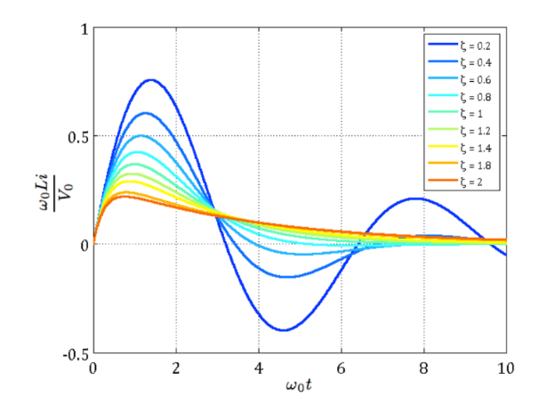

**Figure 3. Non-dimensional discharge current waveforms of a simple RLC circuit for different damping ratio (1).**

The current parameter $ψ$ is defined as the time integral of the current squared over the discharge duration and can be expressed as below:

|  |  |  |
| --- | --- | --- |
| $$ψ=\int_{0}^{t_{0}}{ⅈ^{2}\left(t\right)ⅆt}$$ |  | (18) |

1. **DYNAMICAL MODEL**

The PPT can operate in two different modes depending on the details of the heat transfer and acceleration process. The mode of discharge operation is stationary "ablation-arc" type, when the heat transfer is sufficient for the propellant surface to provide new electrically conducting material, allowing the discharge path to remain adjacent to the surface. On the other hand, for insufficient heat transfer, the discharge is forced to follow the accelerated particles at high velocities which causes the PPT to operate in a propagating or "slug" mode (2).

The working of PPT revolves around the self-applied magnetic field which accelerates the mass. The plasma sheet under acceleration is the only movable element and its position and velocity determine the discharge current which gives rise to the magnetic field which consequently makes the general dynamical problem nonlinear. The uncertainty in the microscopic details of the acceleration process further raises the complexity of the problem. As a result, electromagnetic models have been developed to represent the coarse dynamical features of the acceleration process for the solid propellant thruster, thereby, enabling an analytical approach to this problem (2).

The slug model describes the acceleration of the plasma along the electrodes. Under this model, it is assumed that the total propellant mass is ablated at once in the initial discharge at the minimum inductance configuration and is accelerated as a single layer where mass remains constant throughout the acceleration. There will be a constant change in the inductance of the plasma sheet with regards to position when it is assumed that all ablated mass is accelerated simultaneously and the magnetic field within the circuit is constant. The resistance of the resonant circuit is assumed to be constant over time. It is also considered that the magnetic field is zero outside the circuit and constant and uniform between the electrodes in the direction of the y-axis. The current density within the plasma layer is considered to be uniform and constant and any displacement current is neglected (2).

Acceleration may be described by Newton's second law, generally, where force F is applied to a constant mass m producing an acceleration $\ddot{x}$ (2).

|  |  |  |
| --- | --- | --- |
| $$∑F\left(t\right)=m_{bit}\frac{ⅆ^{2}x_{P}}{ⅆt^{2}}=\int_{V_{P}}{\left(j×B\right)ⅆV_{P}}$$ |  | (19) |

where, $V_{P}$ is the volume of the plasma sheet and $x_{P}$ is the displacement of the current sheet from its initial position. Subsequently, with the exhaust velocity of the accelerated particles directed along the axis of the thruster (positive x-direction), the resulting magnetic assumes the form (2):

|  |  |  |
| --- | --- | --- |
| $$B=B\hat{y}$$ |  | (20) |

The uniform current density within the plasma in the slug model can be represented by (2):

|  |  |  |
| --- | --- | --- |
| $$j\left(t\right)=-\frac{ⅈ(t)}{w}\hat{z}$$ |  | (21) |

Thus, Eq. (19) simplifies as below for the electromagnetic thrust component (2):

|  |  |  |
| --- | --- | --- |
| $$T_{EM}=i(t)\hat{x}\int_{0}^{h}{\int_{0}^{w}{\int_{x_{P}\left(t\right)}^{x_{P}\left(t\right)+δ}{\frac{1}{w} B}dxdydz}}$$ |  | (22) |

Further, modeling of the inductance can be done by defining the magnetic field within the circuit by the total magnetic flux through a surface in the xz-plane and can be obtained by integrating over the electrodes, such that (2)

|  |  |  |
| --- | --- | --- |
| $$ϕ(t)=\left(L_{0}+ΔL\right)ⅈ\left(t\right)=L_{0}ⅈ\left(t\right)+\int_{0}^{h}{\int_{0}^{x_{P}}{ B}ⅆxdz}$$ |  | (23) |

where *B* is the magnetic field between the electrodes and *dxdz* is the surface element on a closed path around the current ***i*** that is encircled by the circuit.

Combining the constant model and dynamical model using a one-dimensional approach to consider PPT as an electromechanical device. Eq. (6) and Eq. (22) of the system can be viewed as

|  |  |  |
| --- | --- | --- |
| $$m_{bit}{\ddot{x}}_{p}\left(t\right)-i\left(t\right)\int_{h}{\int_{w}{\int_{δ}{\frac{1}{w} B}dxdydz}}=0$$ $$i\left(t\right)\left[R+L^{'}{\dot{x}}_{P}(t)\right]+\dot{i\left(t\right)}L+\frac{1}{C}\int_{0}^{t_{o}}{i\left(t\right)dt}-V_{o}=0$$ |  | (24a)  (24b) |

Since the current is assumed to be constant with respect to geometry, the geometric change in inductance can assume the following form (2):

|  |  |  |
| --- | --- | --- |
| $$ΔL(x_{p},y)=\frac{1}{i(t)}\int_{0}^{h}{\int_{0}^{x_{p}}{Bdxdz}}$$ |  | (25) |

The surface *dxdz* depends on the position $x_{p}$ from the surface of the propellant and the change in inductance varies accordingly. The average change in inductance across the width of the electrodes will show the average change in inductance as a function of the plasma sheet, and can be expressed as below (2):

|  |  |  |
| --- | --- | --- |
| $$Δ\overline{L}(x_{p})=\frac{1}{i(t)}\int_{0}^{w}{\int_{0}^{h}{\int_{0}^{x_{p}}{\frac{1}{w} B}dxdzdy}}$$ |  | (26) |

Hence, we obtain a simplified equation for the system (2)

|  |  |  |
| --- | --- | --- |
| $$m_{bit}{\ddot{x}}_{p}\left(t\right)-Δ\overline{L}\left(x_{p}\right){\left[i\left(t\right)\right]}^{2}=0$$ |  | (27) |

For simplicity, it has been approximated that the discharge channel geometry is of a quasi-infinite width (w >> h) and is one-turn solenoid made of perfectly conducting sheets of uniform current density. The magnetic field in this simple and symmetric enough geometry, is generated by a slowly alternating electric current can be described using Ampere's circuital law which implies that for any closed loop path, the sum of the length elements times the magnetic field in the direction of these elements is proportional to the electric current which is enclosed in the loop with the permeability as proportional constant and can be represented as below (2):

|  |  |  |
| --- | --- | --- |
|  |  | (28) |

The self-induced magnetic field in PPT is directed along the thruster width and is in accordance with the slug model, the integration over the plasma sheet has been done by assuming that no magnetic field outside of the solenoid exists, so that (2)

|  |  |  |
| --- | --- | --- |
| $$B(x,t)=\left\{\begin{aligned}μ \frac{ⅈ(t)}{w}\hat{y} , & 0<x<x_{p}(t) \\ 0, &x>x_{p}(t)+δ\end{aligned}\right.$$ |  | (29) |

Where, due to the diamagnetic properties of the plasma, $μ=μ_{o}$ is the vacuum permeability. The magnetic field throughout the current will also depend on the position relative to the current sheet position and can be evaluated by applying Ampere's law to a surface *S* passing through the plasma sheet. Using the magnetic field inside the solenoid as a boundary condition so that the magnetic field within the current sheet will increase linearly with the distance from the plasma propellant surface helps us to obtain a full description of the magnetic field (4).

|  |
| --- |
| $$B(x,t)=\left\{\begin{aligned}μ \frac{ⅈ\left(t\right)}{w}\hat{y} , & 0<x<x_{p}\left(t\right) (inside solenoid) \\ μ\frac{ⅈ\left(t\right)}{w}\left(1-\frac{x-x_{p}\left(t\right)}{δ}\right)\hat{y},x_{p}\left(t\right)≤x{≤x}_{p}\left(t\right)+δ \\ (throughout plasma sheet) \\ 0, x>x_{p}\left(t\right)+δ (outside solenoid)\end{aligned}\right.$$ |
| (30) |

Inserting the above into Eq. (22) yields the electromagnetic force experienced by the electrode (2)

|  |  |
| --- | --- |
| $$T_{EM}=h\frac{i(t)}{δ}\hat{x}\int_{x_{P}\left(t\right)}^{x_{P}\left(t\right)+δ}{μ_{0}\frac{ⅈ\left(t\right)}{w}\left(1-\frac{x-x_{p}\left(t\right)}{δ}\right)}dx=μ_{0}h\frac{{[ⅈ\left(t\right)]}^{2}}{δw}\hat{x}\int_{0}^{δ}{\left(1-\frac{x}{δ}\right)}dx=μ_{0}h\frac{{[ⅈ\left(t\right)]}^{2}}{δw} {[x-\frac{x^{2}}{2δ}]}_{0}^{δ} \hat{x} =\frac{μ_{0}}{2}\frac{h}{w}{[ⅈ\left(t\right)]}^{2}\hat{x}$$ | (31) |

The dynamic equation for the system can be then expressed as below (2)

|  |  |  |
| --- | --- | --- |
| $$m_{bit}{\ddot{x}}_{p}=\frac{μ_{0}}{2}\frac{h}{w}{\left[ⅈ\left(t\right)\right]}^{2}\hat{x}$$ |  | (32) |

Comparing with Eq. (23) the inductance gradient contribution from parallel electrodes can be expressed as (2):

|  |  |
| --- | --- |
| $$L_{PE}\left(x_{p}\left(t\right)\right)=\frac{1}{i\left(t\right)}\iint_{electrode}{B\left(x,y\right)}.dS$$ $$=\frac{μ_{o}}{w}\left[\int_{0}^{x_{p}\left(t\right)}{\int_{0}^{h}{dxdy}}+\int_{x_{p}\left(t\right)}^{x_{p}\left(t\right)+δ}{\int_{0}^{h}{\begin{aligned}\left(1-\frac{x-x_{p}\left(t\right)}{δ}\right)\end{aligned}}}dxdy\right]$$ $$=μ_{o}\frac{h}{w}\left(x_{p}\left(t\right)+\frac{δ}{2}\right)$$ |  |
| (33) |  |

The inductance gradient takes the following form (2):

|  |  |  |
| --- | --- | --- |
| $${L^{'}}_{PE}=\frac{{dL}_{PE}}{dx_{p}\left(t\right)}=μ_{0}\frac{h}{w}$$ |  | (34) |

In the case of infinitesimal plasma sheet thickness, $δ→0$ parallel electrodes and a planar current sheet that remains perpendicular to the electrodes, the inductance model then reduces to the following form (2)

|  |  |
| --- | --- |
| $$L=L_{o}+\left(\frac{dL }{dx}\right)x=L_{o}+μ_{0}\frac{h}{w}x_{p}\left(t\right)$$ $$=L_{o}+{L^{'}}_{PE}x_{p}\left(t\right)$$ | (35) |

The dynamics of the system can be defined as below (2):

|  |  |  |
| --- | --- | --- |
| $$m_{bit}{\ddot{x}}_{p}\left(t\right)-\frac{μ_{0}}{2}\frac{h}{w}{[ⅈ\left(t\right)]}^{2}=0$$ $$\left[L_{o}+μ_{0}\frac{h}{w}x_{p}\left(t\right)\right]\dot{i\left(t\right)}+\left[μ_{0}\frac{h}{w}{\dot{x}}_{p}\left(t\right)+R\right]i\left(t\right)+\frac{1}{C}\int_{0}^{t}{i\left(τ\right)dτ}-V_{o}=0$$ |  | (36a)  (36b) |

and the trivial initial conditions can be represented as below (2):

|  |  |
| --- | --- |
| $$x_{p}\left(0\right)=0; {\dot{x}}_{p}\left(0\right)=0; \int_{0}^{t=0}{i\left(τ\right)dτ}=0; i\left(0\right)=0$$ | (37) |

The solution for $i\left(t\right)$ and $x_{p}\left(t\right)$ can be evaluated as below and hence the system can be visualized as a set of four first-order differential equations by introducing the state space variables (2).

|  |  |
| --- | --- |
| $$x_{1}\left(t\right)=x_{p}\left(t\right)$$ | (38a) |
| $$x_{2}\left(t\right)=\int_{0}^{t}{i\left(τ\right)dτ}$$ | (38b) |
| $$x_{3}\left(t\right)={\dot{x}}_{p}\left(t\right)$$ | (38c) |
| $$x_{4}\left(t\right)=i\left(t\right)$$ | (38d) |

The above equations help in representing the system in a simpler form (2):

|  |  |
| --- | --- |
| $${\dot{x}}_{1}\left(t\right)=x_{3}\left(t\right)$$ | (39a) |
| $${\dot{x}}_{2}\left(t\right)=x_{4}\left(t\right)$$ | (39b) |
| $${\dot{x}}_{3}\left(t\right)={\ddot{x}}_{p}\left(t\right)=\frac{μ_{0}}{2m_{bit}}\frac{h}{w}{[ⅈ\left(t\right)]}^{2}=\frac{μ_{0}}{2m_{bit}}\frac{h}{w}{[x_{4}\left(t\right)]}^{2}$$ | (39c) |
| $${\dot{x}}_{4}\left(t\right)=\dot{i\left(t\right)}=\frac{V_{o}-\frac{1}{C}x_{2}\left(t\right)-(μ_{0}\frac{h}{w}x_{3}\left(t\right)+R)x_{4}\left(t\right)}{L_{o}+μ_{0}\frac{h}{w}x_{1}\left(t\right)}$$ | (39d) |

Simple electrodes geometries help in visualizing and understanding the dynamics in case of the parallel rectangular electrodes while flare non-rectangular electrodes can be visualized as complex electrode geometries.

1. **LUMPED CIRCUIT ANALYSIS MODEL**

The kinematic modeling used in the study for PPT is based on a lumped circuit analysis model. The lumped circuit analysis model assigns each component a resistance, inductance or capacitance accordingly (4).

According to Faraday law, the induced electromagnetic force in any closed circuit is equal to the time rate of change of the magnetic flux through the circuit.

The inductance of the plasma, $L_{p}$ is found from the magnetic flux through the plasma. However, for a Gaussian surface which surrounds the plasma bulk, the magnetic flux is zero (4).

|  |  |  |
| --- | --- | --- |
| $$L_{p}=\frac{ϕ_{B}}{I}=\frac{1}{I}\oint{B⋅ⅆS=0}$$ |  | (40) |

The lumped circuit analysis model is used to evaluate $ϕ_{wall}$ at any given time. The limitation in the arc current by space-charge effects can be assumed to be a pseudo resistance for the lumped circuit analysis model. Using Ohm's law, the limited arc current and the potential difference between the sheath and the sheath wall, the total plasma resistance (considering the plasma resistance to be relatively small) can be represented as below (4):

|  |  |  |
| --- | --- | --- |
| $$R_{p}=R_{sheath}+R_{plasma flow}≈\frac{V_{5sheath}}{I_{sheath}}$$ |  | (41) |

One of the main limiting factors of the lumped circuit analysis model is the assumption of the constant values to describe the plasma that does not fluctuate with time or current. We use the simplified magnetohydrodynamic flow model based on the quasi-steady-state assumption to overcome the limitations of the lumped circuit analysis model.

1. **PLASMA FLOW MODEL**

The plasma flow model was based on observations found in the literature. The plasma model discussed is independent of the propellant used. It was assumed that the plasma mass originates from the electrode surface and flows towards the anode rather than a plasma bulk originating from a solid propellant between the electrodes. The flow model shows that along the flow at certain distances, the plasma creates a "choke", where the flow radius is small. In the choke the electron temperature, electron density and mean ion charge state rise significantly. The experiments in literature used high-speed photography to show the erosion of electrodes in condensed areas by a high energy process, which forms carters as a byproduct. The high-speed photography showed in detail bright spots on the surface of the electrode and formation of a small but intense jet from those bright spots. The process starts with the formation of emission centers which are those bright spots located on the cathode. The metal surfaces are not smooth at the microscopic scale. Field emission occurs at geometric sharp points, thereby, resulting in ion bombardments in those places. The emission site heats rapidly and thermionic emission of electrons occurs with the increase in ion bombardment. The increased presence of electrons further increases ion bombardment resulting in a thermal runaway. The surface of the electrodes heats rapidly till it explodes leaving a visible crater. The crater edge with its rough surface, thereby, forming a location for secondary cathode spots to form (4).

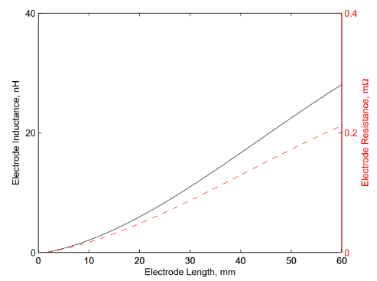

**Figure 4. Electrode inductance and resistance as a function of length (4)**

The current flowing through the plasma during the discharge, is of the order of kilo ampere, resulting in a self-constricting magnetic field within the plasma. The magnetic force is balanced out by the ideal gas pressure exerted by the highly energetic electrons forming a plasma column. When the current is in the considerable range of $≥1kA$, a sausage instability occurs within the plasma and pinch is created within the column. The pinch constriction forms a localised area having an increased particle number density with an increased probability of particles colliding. The particle temperature rises substantially because of the increased collisions and the plasma is ionized further into higher ion charge states. Moderate to high current flowing through the system forms the plasma column. The column origin in close proximity to the cathode is an area of enhanced cathode spot activity. The close proximity of cathode spots to each other results in the amalgamation of their plasma jets forming a single plasma flow in an area called mixing region. The plasma flow originates from a single or closely grouped number of cathode spots rather than several individual plasma flows from spots that are at distances far from each other. The discharge is a short pulse arc with quasi-steady state. The model in this study uses a one-dimensional system of equations taking into account that the plasma flow cross-sectional area, $S=πr^{2}$. It is considered that the plasma temperature, electron density, ion velocity, ion charge state and the current density across the cross-sectional area are uniform (4).

The initial copper plasma has a velocity, $V_{Z}$ of 13.2 $km∕s$ towards the direction of the anode and has an average mean ion state of ${Cu}^{2+}$. The number of cathode spots observed during discharge is proportional to the overall arc current which is flowing through the system. It has been experimentally observed that the current observed per spot $I_{spot}$ for copper is $150±70 A$. It has been experimentally observed and estimated that the radius of the cathode spots is $1-2μm$ for copper (4).

The dimensions of plasma flow are dependent on the number of plasma jets which are present within the discharge which is equivalent to the number of cathode spots. The plasma jet is thought to expand parabolically with a circular aperture at its end face. The total area of the mixing region is taken to be a function of the initial surface area from a single plasma jet, which originates from a single cathode spot and is multiplied by the total number of cathode spots; and can be expressed as below (4):

|  |  |  |
| --- | --- | --- |
| $$S_{o}=S_{spot}\frac{I_{arc}}{I_{spot}}$$ |  | (42) |

The electron temperature of the plasma increases with the collision frequency of electrons and ions. This results in an increase in the plasma pressure but a decrease in the flow velocity of the plasma. Subsequently, with the decrease in the velocity, the cross-sectional area of the plasma flow decreases, thereby, increasing the electron density. The plasma pressure further increases in a runaway effect causing the plasma flow to become stationary. It is assumed that the electron temperature within the plasma flow cannot exceed a critical temperature of $T_{cr}$ which puts a limit on the growth. The critical temperature can be expressed as below (4):

|  |  |  |
| --- | --- | --- |
| $$T_{cr}=\frac{75M^{2}T_{m}{\overline{Q}}_{0}}{192\overline{Q}}$$ |  | (43) |

where *M* is the Mach number for all plasma jets that originate from a cathode surface is $≅3.5$.

Collisions between the electrons and ions within the plasma can be considered as binary collisions. However, due to the relative masses, velocities and sizes, an electron is more likely to be scattered by a small amount because of the interaction of the coulomb forces between the particles rather than a larger deflection because of a direct impact between the particles. The small scatter in a single collision event is more advantageous in describing the effect of numerous smalls scatter event instead of describing the collision process by a direct collision. The frequency $ν_{ie}$ at which electrons and ions collided can be expressed using the following equation (4):

|  |  |  |
| --- | --- | --- |
| $$ν_{ie} =3.62×{10}^{-6}\frac{Λ{N_{e}T}_{e}^{-3/2}}{\overline{Q}}$$ |  | (44) |

Where, $\overline{Q}$ is the mean ion charge state in the plasma flow and has a value of 2.06 for copper electrodes. $T_{e}$ is the electron temperature in a plasma flow model and is 11605 K.

The coulomb logarithm, $Λ$ describes the factor by which small-angle collisions are more effective than the large-angle collisions. the Coulomb logarithm in a short duration vacuum arc for the plasma conditions can be defined as (4):

|  |  |  |
| --- | --- | --- |
| $$Λ=23-\log{({N_{e}^{2}\overline{Q}T}_{e}^{-3/2})}$$ |  | (45) |

The electron density can be expressed as a function of arc current and defined as below (4):

|  |  |  |
| --- | --- | --- |
| $$N_{e}=\frac{Iα_{\dot{i}}}{ⅇSV_{z}}$$ |  | (46) |

Where, $N_{i}=\frac{N_{e}}{\overline{Q}}$ is the ion density assuming quasi-state neutrality.

The plasma conductivity can be defined using Ohm's law as below (7):

|  |  |  |
| --- | --- | --- |
| $$σ_{o}=\frac{N_{e} e^{2}}{m_{e} ν_{ie}}$$ |  | (47) |

The resistance of the plasma can be evaluated from the inverse of conductivity and by integrating it across the distance between the electrodes. The plasma flow resistance is minimal in comparison to the effective resistance seen across the voltage drop in the sheath regions (4).

|  |  |  |
| --- | --- | --- |
| $$R_{Plasma flow}=\int_{0}^{h}{\frac{1}{σ_{o}\left(z\right)} dz}$$ |  | (48) |

Plasma is insulated from the environment that surrounds it by the natural sheaths that are created when plasma interacts with the surface. The sheath is dynamic in structure and its thickness depends on the potential difference between the solid surface and the plasma potential. During the creation of the cathode spot, the introduction of charge and mass through emission sites affect the cathode sheath. When the potential of the solid surface rapidly changes, the change in the electric field makes the electrons leave immediately while the slower the heavier ions are fixed for a small duration. This type of sheath is the ion matrix sheath and its thickness is (4):

|  |  |  |
| --- | --- | --- |
| $$δ_{p}=\sqrt{-ϕ_{wall}\frac{2 e_{o}}{e N_{i} }}$$ |  | (49) |

1. **ELECTRODE EROSION MODEL**

Cathode spots, in which the plasma originates, formed on the same material are similar. That has allowed experimentalists to characterize parameters like $α_{\dot{i}}$, for different materials used for electrodes. $α_{\dot{i}}$ is the ion normalized by arc current and is used to describe the ratio between the ion current and the arc current in a cathodic plasma. For electrodes of copper, $α_{\dot{i}}=0.114$. The ion erosion rate, $Γ_{i}$ is the total ion mass eroded from the surface of the electrode per unit charge. For copper, $Γ_{i}=33.4 μg{ C}^{-1}$ (4). The number of pulses considered in the tool is 5×105.

Hence, the rate of mass loss from the surface of the electrode as a function of discharge current can be represented as below (4):

|  |  |  |
| --- | --- | --- |
| $$\frac{dm}{dt}=\frac{dm}{dQ}\frac{dQ}{dt}⇒Γ_{i}I$$ |  | (50) |

The graph below represents the variation in ion current for different cathode materials.

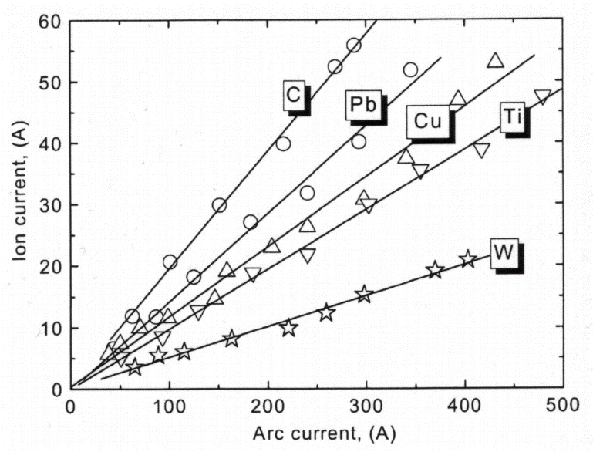

**Figure 5. Ion current as a function of arc current for different cathode materials (4)**

When measured experimentally, the total mass eroded should be higher than found from Eq. (3) because of the ejection of macro particle and neutral particle, which are produced from the cathode crater as it cools down after the explosion. Macro particles have increased mass and get accelerated at a slower rate than the plasma ions and electrons. Their effect on plasma dynamics is, therefore, neglected (4).

Neutral particles are neglected, for any PPT without PTFE. Since most of the particles during the cathode spot process are ions, there is no significant source of neutrals present. Additionally, neutrals occurring from cooling sites are formed on timescales longer than the discharge process and hence, assumed not to interact or have an effect on the discharging plasma (4).

**PPT PERFORMANCE PARAMETERS**

1. **EXHAUST VELOCITY, $v_{e}$**

The velocity of the accelerated particles at the end of the acceleration channel, where the position of the plasma sheet equates the length of the electrodes, as mentioned below (2):

|  |  |  |
| --- | --- | --- |
| $$v_{e}={\dot{x}}_{p}(t_{o})$$ |  | (51) |

Where, $t_{o}$ is the time the plasma sheet takes to reach the end of the electrodes and ${\dot{x}}_{p}$ is the state space variable $x_{3}$ (t) represented in Eq. (39) representing the velocity of plasma at instant *t*.

1. **SPECIFIC IMPULSE, $I_{sp}$**

The specific impulse predicts the efficiency of conversion of propellant into thrust, in a propulsion system. The specific impulse can be evaluated as below (2):

|  |  |  |
| --- | --- | --- |
| $$I_{sp}=\frac{1}{m_{bit}g}\int_{0}^{t_{o}}{T_{EM}dt}=\frac{v_{e}}{g}$$ |  | (52) |

In the study, the graph from Guman and Palumbo and by Gessini and Paccani was used in the case for micro pulsed plasma thruster to get a good estimation of specific impulse.

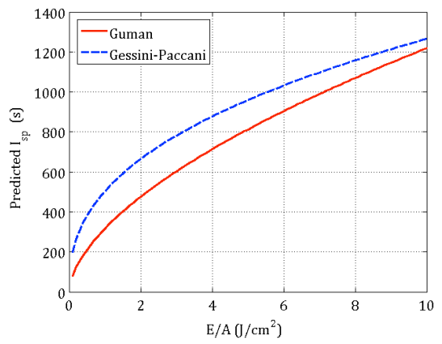

**Figure 6. Semi-empirical specific impulse trend with E/A (1)**

1. **IMPULSE BIT, $I_{bit}$**

The thrust force produced has a pulsating nature which facilitates the need to measure it as an impulse. The impulse bit describes the momentum generated by the thruster during one pulse by accelerating the mass $m_{bit}$ to the average exhaust velocity $v_{e}$ (2).

For thruster with *a*<<1, the electromagnetic impulse bit acting on the plasma sheet, can be evaluated using the following relation (3,2):

|  |  |  |
| --- | --- | --- |
| $$I_{bit}=\frac{1}{2}\frac{h}{w}μ_{0}\int_{0}^{t_{o}}{{ⅈ\left(t\right)}^{2}dt}=m_{bit}I_{sp}gf$$ |  | (53) |

In the case of ppt with a larger aspect ratio, Guman developed an analytic formula that considered both the electromagnetic and electrothermal contribution of $I_{bit}$ (6):

|  |  |  |
| --- | --- | --- |
| $$I_{bit}=\frac{1}{2}\frac{h}{w}μ_{0}\int_{0}^{t_{o}}{{ⅈ\left(t\right)}^{2}dt}+\sqrt{\frac{8\left(γ-1\right)}{γ^{2}(γ+1)}ΔmE_{o}}$$ |  | (54) |

The above expression only gives an approximation of the $I_{bit}$ because it assumes that the flow expansion occurs at the constant area and that all of the energy $E_{o}$ is added to the arc before any mass $Δm$ ablates (6).

1. **THRUST**

PPT being an electromagnetic device accelerates plasma particles to velocities of the order of 10 km/s which produces thrust. When a pulsed, high current arc discharge which lasts few microseconds is produced between two electrodes, it gets ionized and heated; and as a result, accelerates the propellant particles through the Lorentz force generated by the interaction between the discharge and the self-induced magnetic field. The thrust level is generally regulated by controlling the pulse repetition rate rather than varying the energy level, while the single-shot impulse is usually very stable and repeatable (1).

Thrust in PPT is classified into two components, the electromagnetic and electrothermal. The electromagnetic part is obtained from the Lorentz force law by analyzing the behaviour of charged particles in the magnetic field. The electrothermal component is derived in the basis of the $j×B$ force with electrode thickness, spacing and plasma sheet thickness (3,2).

The ET and EM components of thrust can be expressed as below (2):

|  |  |  |
| --- | --- | --- |
| $$T_{EM}=f\frac{L^{'}}{2}\int_{0}^{t_{o}}{{ⅈ\left(t\right)}^{2}dt}=I_{bit}*f$$ |  | (55) |

|  |  |  |
| --- | --- | --- |
|  |  | (56) |

Where, $γ$ is a dimensionless constant dependent on the material of the propellant. For PTFE, its value is, $γ_{PTFE}=1.3$.

The thrust then adds up to the following:

|  |  |  |
| --- | --- | --- |
| $$T=T_{EM}+T_{ET}$$ |  | (57) |

Under most circumstances, when the electromagnetic component is compared to the electrothermal component, the electrothermal contribution is found sufficiently small to be neglected.

1. **EFFICIENCY, $η$**

The efficiency of the thruster can be defined as the ratio of the propellant axial kinetic energy to the energy stored in the capacitor and can be evaluated as below (1):

|  |  |  |
| --- | --- | --- |
| $$η=\frac{m_{bit} kinetic energy}{capacitor stored energy}=\frac{\frac{1}{2}m_{bit}{v_{e}}^{2}}{E_{o}}$$ |  | (58) |

The efficiency of the thruster can be split into the product of the energy transfer efficiency $η_{tr}$ and the acceleration efficiency $η_{acc}$ (1).

|  |  |  |
| --- | --- | --- |
| $$η=η_{tr} η_{acc}$$ |  | (59) |

The energy transfer efficiency is the fraction of the energy stored in the capacitor which is delivered to the arc discharge and is determined by the ESR of the capacitor and the impedance of the PPT $Z_{PPT}$. The acceleration efficiency is the fraction of energy which is transferred to the plasma sheet and is transformed into thrust energy.

The total impedance of the discharge circuit can be written as (1):

|  |  |  |
| --- | --- | --- |
| $$Z_{TOT}=Z_{PPT}+Z_{TRANS}+ESR$$ |  | (60) |

where, $Z_{TRANS}$ is the impedance of the transmission line between the capacitor and the thruster (this term can be neglected for a well-designed PPT as its value is very small).

The transfer efficiency then takes the following form (1):

|  |  |  |
| --- | --- | --- |
| $$η_{tr}=\frac{Z_{PPT}}{Z_{TOT}}=\frac{Z_{TOT}-ESR}{Z_{TOT}}=1-\frac{ESR}{Z_{TOT}}$$ |  | (61) |

1. **INDUCTIVITY**

The average inductance change or inductivity for both simple and complex geometries can be evaluated by using the following expression (2):

|  |  |
| --- | --- |
| $$Δ\overline{L}\left(x_{p}\right)=\frac{μ_{o}}{2π}\int_{0}^{h\left(x\right)}{\int_{0}^{w\left(x\right)}{\int_{0}^{x_{p}}{\frac{1}{w^{2}}{[tan}^{-1}{\frac{y}{z}}+\tanh^{-1}{\frac{w-y}{z}}+\tan^{-1}{\frac{y}{h-z}}+\tan^{-1}{\frac{d-y}{h-z}}}] dxdydz}}$$ | (62) |

The spacing between electrodes and its width can be represented as below for complex geometry (2):

|  |  |  |
| --- | --- | --- |
| $$h\left(x\right)=h_{o}+2 \tan{(α)}x$$ |  | (63) |

|  |  |  |
| --- | --- | --- |
|  |  | (64) |

Where, $h_{o}$ and $w_{o}$ are base spacing and width of electrodes respectively and $w_{tip}$ is the width of the tip of the electrode. In tongue-shaped electrode geometry $\frac{w_{tip}}{w_{o}}→0$. The above Eq. (62) can be simplified and represented as below and was used in the tool suggested in this paper (2):

|  |  |  |
| --- | --- | --- |
| $$Δ\overline{L}\left(x_{p}\right)=\frac{μ_{o}}{2π}\int_{0}^{x_{p}}{f \left(x,h\left(x\right),w\left(x\right)\right)dx}$$ |  | (65) |

where,

|  |  |
| --- | --- |
| $$f \left(x,h\left(x\right),w\left(x\right)\right)=\frac{2h(x)}{w(x)}\left[π-2\tan^{-1}{\frac{h\left(x\right)}{w\left(x\right)}}+\frac{h\left(x\right)}{w\left(x\right)}\ln\left(h\left(x\right)\right)\right]-2ln\left(w\left(x\right)\right)+\left(1-\frac{[{h(x)]}^{2}}{{\left[w\left(x\right)\right]}^{2}}\right)ln⁡([{h(x)]}^{2}+[{w(x)]}^{2})$$ | (66) |

**PERFORMANCE ASSESSMENT TOOL**

The GUI has been developed in MATLAB. It provides two distinct analysis for micro and large PPT by using the knowledge of various electrical and geometrical parameters. The user can also analyze the variation in performance parameters (efficiency, impulse bit, exhaust velocity and thrust) for variations in electrode dimensions (spacing and width). Thus, giving a deeper insight into the optimal design of the thruster for the specific objective of the mission. It provides the user with the option to save and import parameters.

1. **Micro-PPT PERFORMANCE ANALYSIS**

In the study, we classify micro PPT for any thruster designed with *a*<2. The tool in the section of micro PPT considers only the electromagnetic contributions of the processes. The $I_{sp}$ obtained from the assessment tool can be verified using the Guman and Gessini-Paccani graph.

1. **LES-8/9**

The PPT used in LES-8/9 mission used twin fuel bars contained in rectangular parallel plates that were breech fed and canted at 30° to the thruster axis. Experimentally, the impulse bit was found to vary from 267 to 352 µN-s, averaging 297 µN-s over 2×107 pulses on varying the annular plug gap from 2 to 11 mm (6). Some parameters were not available publicly so they were assumed based on practicality. Table 1 below compares parameters of PPT for LES-8/9 in the real-time and the values obtained using the assessment tool.

|  |  |  |
| --- | --- | --- |
| **Parameters** | **Real-Time** | **Assessment Tool** |
| Stored Energy | 20 J | 20 J |
| Capacitance | 17 µF | 17 µF |
| Pulse Rate | 1.0 Hz | 1.0 Hz |
| Specific Impulse | 1000 s | 996 s |
| Impulse bit | 297 µN-s | 241 µN-s |

**Table 1: Comparison between real-time parameters and assessment tool parameters for LES-8/9**

Figure 7 in annex A gives an insight into the analysis of LES-8/9 observed using the assessment tool.

1. **LARGE-PPT PERFORMANCE ANALYSIS**

In the assessment tool, there is a distinct page for thrusters with *a*>2. The calculations in this section consider both the electrothermal and electromagnetic effects in a thruster and then estimates the performance of the thruster for given electrode dimensions and electrical specifications.

1. **LES-6**

The measurements of LES-6 were taken by Solbes and Vondra, by varying parameters, electrode gap=3.0 cm, width=1.0 cm, length 0.6 cm, capacitance from 0.66 to 6.0 µF, the voltage from 500 to 2000 V, external resistance from 0 to 0.80 Ω, external inductance from 50 to 650 H. The specific impulse was observed to be in the range of 200-590 s (6). Some parameters were not available publicly so they were assumed based on practicality. Table 2 below compares parameters of PPT for LES-6 in the real-time and the values obtained using the assessment tool.

|  |  |  |
| --- | --- | --- |
| **Parameters** | **Real-Time** | **Assessment Tool** |
| Stored Energy | 1-7 J | 7 J |
| Capacitance | 0.66 to 6.0 µF | 6.0 µF |
| Inductance gradient | 0.95 µH | 0.96 µH |
| Pulse Rate | 1.0 Hz | 1.0 Hz |
| Specific Impulse | 200-590 s | 505 s |
| Impulse bit/J at 7 J | ~80 µN-s/J | 81 µN-s/J |

**Table 2: Comparison between real-time parameters and assessment tool parameters for LES-6**

Figure 8 in annex A gives an insight into the analysis of LES-6 done using the tool.

# CONCLUSIONS

The performance assessment tool suggested in this study can help a thruster designer to evaluate the necessary performance parameters required to carry on and complete the objective planned for the mission. As can be seen through comparison with true flight hardware, this tool can estimate correct values of various parameters for a well-designed thruster. The tool was checked against the values of LES-8/9 and LES-6 to help us verify the functioning of the tool.

**REFERENCES**

1. F. Guarducci, 2011, “Design and Testing of a Micro PPT for a Cubesat Applications,” PhD Thesis, Sapenzia, Universita di Roma.
2. Veronica Wall $\ddot{a}$ ngen, 2014, “Analytical Modeling of a Microthruster System for Nanosatellite Applications,” Master of Science Thesis, Royal Institute of Technology, Sweden.
3. Molina-Cabrera P., Herdrich G., Lau M., Fausolas S., Schoenherr T., Komurasaki K., 2011, “Pulsed Plasma Thrusters: a Worldwide Review and Long Yearned Classification,” 32nd International Electric Propulsion Conference.
4. Peter Vallis Shaw, 2011, “Pulsed Plasma Thrusters for Small Satellites,” PhD Thesis, University of Surrey, UK.
5. Rodney L. Burton, 2010, “Pulsed Plasma Thrusters,” Encyclopedia of Aerospace Engineering, John Wiley & Sons, Ltd.
6. R. L. Burton, P. J. Turchi, 1998, “Pulsed Plasma Thruster,” Journal of Propulsion and Power, Vol. 14, No. 5.
7. Pavel Sou $\check{c}$ ek, 2011, “Plasma Conductivity and Diffusion”.

**ANNEX A**

**Performance Assessment using GUI**

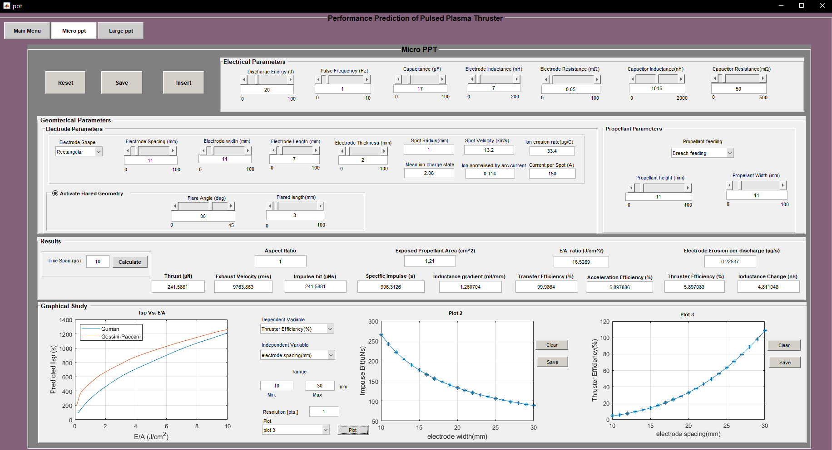

**Figure 7. LES-8/9 analysis using assessment tool**

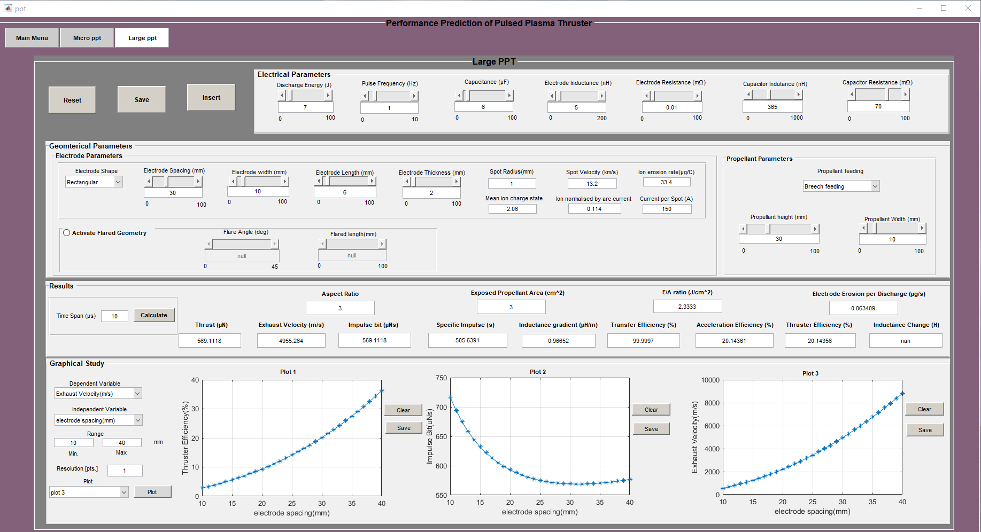

**Figure 8. LES-6 analysis using assessment tool**